Balancing Community and Commerce
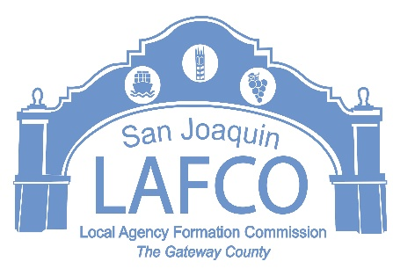
5000 S. AIRPORT WAY SUITE 209 STOCKTON, CA 95206 209-953-7646
TO:
City of Tracy | SJC Administrators Office
SJC Communiity Development Dept. | SJ County Public Works Dept.
Tracy Rural Fire District | California Highway Patrol
Environmental Health Department | Tracy Unified School District
State of California Dept. of Fish and Wildlife | SJ County Sheriff’s Department
SJ County Resource Conservation District | South County Fire Authority
California Department of Transportation | San Joaquin Valley APCD
Central Valley Regional Water Quality Control Board | SJ Council of Government (HCD)
SJ Flood Control Agency | SJ Council of Government (ALUC)
SJ County Committee on School District | SJC MVCD
California Attorney General Office - Bureau of Environmental Justice

FROM: JD Hightower, Executive Officer

PROJECT: Guru Baaz Annexation to the City of Tracy

REFERRAL DATE: April 7, 2026
----------------------------------------------------------------------------------------------------------------------------------
Proposal: The City of Tracy proposes to annex approx. 3.9 acres for Community Recreation Support Services.

Location: The two parcels are in unincorporated San Joaquin County and are located at 21323 N. Tracy Blvd. and 21235 N. Tracy Blvd., Tracy, CA 95378, The parcels are located at the northwest corner of N. Tracy Boulevard and W. Larch Lane.

Please visit https://www.sjlafco.org/projects-under-review-and-receiving-comments to review application for the above referenced project. Please submit your project-related comments along with any proposed requirements to the LAFCo Office no later than 5:00 P.M. on May 11, 2026. Environmental concerns may also be included in your comments. If a response is not received by this date, we will assume you have no comment.
Please call me directly at (209) 468-3198 if you have any questions or need additional information. Responses may be emailed to jhightower@sjgov.org. Thank you.
----------------------------------------------------------------------------------------------------------------------------------
cc: Carloly Steman, County Assessors Office
Corinne King, Community Developem-Planning
Scott Cooper, Public Services
Dave Bollinger, Community Development Services

